EMPLOYEE RAISE ISSUE – RECORD PRODUCER & SERVICE PORTAL INTEGRATION
PHASE 1: Creating a Custom Application

1. Introduction
This phase establishes the foundation of the Employee Raise Issue solution by creating a custom ServiceNow application. The application provides a dedicated scope for the tables, configurations, portal components, and other project development work.

2. Objective
To create a custom scoped ServiceNow application named Employee Center.

3. Application Configuration
Property | Value
Application Name | Employee Center
Scope | Scoped
Purpose | Foundation for Employee Raise Issue solution

4. Procedure
1. Navigate to All → App Engine → ServiceNow Studio.
2. Click Create.
3. Select App.
4. Enter Employee Center as the application Name.
5. Select Scoped as the scope.
6. Click Continue.
7. Return to the ServiceNow home page and reload the instance.
8. Verify that Employee Center appears as the current application.
ServiceNow Studio – Create Application screen
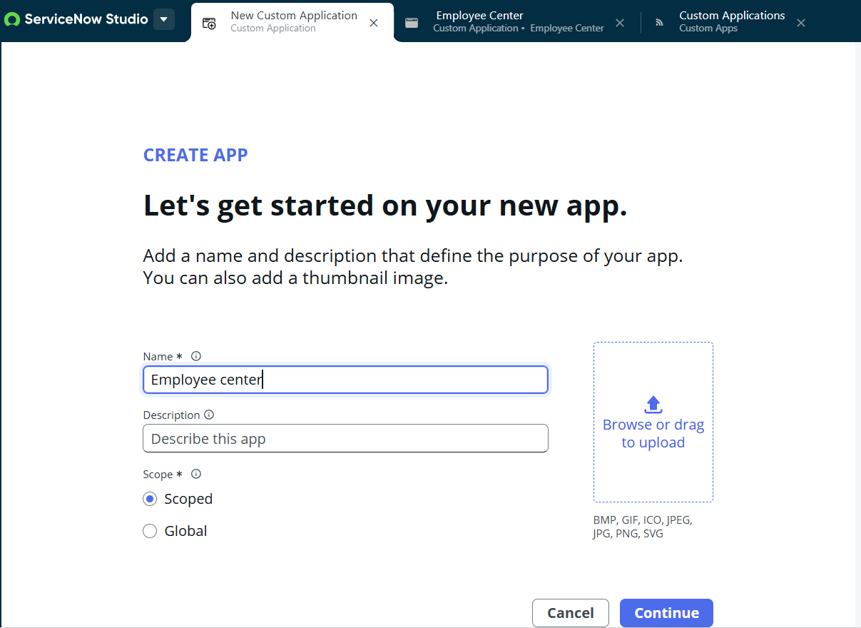
Employee Center application shown as the 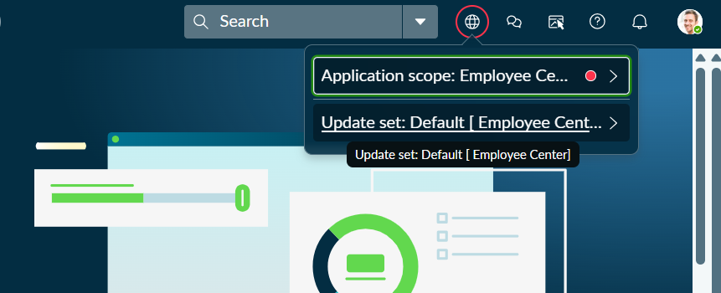current application

5. Result
The Employee Center scoped application was created successfully and is ready for the remaining project development.

